OH-200 All-O-Matic Overhead Gate Opener

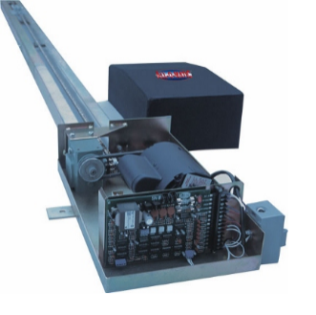

Features
- UL 325 & UL 991 Compliant
- Motor ½ HP
- Duty Cycle Continuous
- Power Options 120 V AC
- Gear Box Ratio 40:1
- Cover Rotationally Molded – Indestructible
- Dimensions W: 13" - L: 144" – H: 8"
- Maximum Gate Length 16 Feet
- Maximum Gate Weight 800 lbs
- Gate Speed Full Cycle in 20s (6'-6" to 8' gate)
- Emergency Release Options Lockable Quick release Drive Arm and Carriage
- Battery Backup Compatible

FIVE YEAR WARRANTY
ALL-O-MATIC, INC. gate operators are warranted against defects in materials and workmanship for five years Commercial. Any part, parts or complete unit found to be defective within this period shall, at the manufacturer’s option, be repaired or replaced free of charges, F.O.B. our factory. The above warranty is in lieu of all other warranties, expressed or implied, and shall be

Owner’s manual link
https://www.elitegates.net/files/PDF/oh200Manual.pdf

