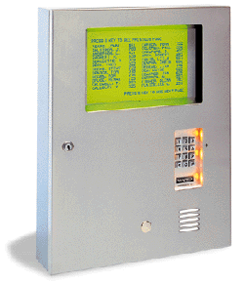 |  | Sentex Infinity DI this is an Apartment Intercoms for more than a 100 units  The Sentex Infinity DI is engineered for exceptional performance and functionality, combining the convenience of telephone entry with the flexibility of access control.  Sentex Infinity Specs  Sentex Infinity Manual  SPECIFICATIONS:  - Directory Codes: 500  - Full Entry Codes with Names: 3000  - Full Entry Codes without Names: 16,000  - Event Buffer: 5800  - Power: 12VAC @ 3.4 amps peak, 13.5VDC @ 2.1 amps (without readers)  - Dimensions: Infinity L & DI Surface Mount 21"H x 16-7/16"W x 4-3/8"D  - Infinity L & DI Flush Mount 21-5/6"H x 16-3/4"W x 3-1/8"D  - Shipping Weight: = 32 lbs.  - This Model Is Discontinued. Please call for possible replacement.

Sentex Infinity DI Features
UNIQUE FEATURES:
- Paper directory insert for typed names
STANDARD FEATURES:
- Full duplex communications
- Long distance and PBX dialing
- Tone/pulse compatibility
- Variable code length
- Battery backup
- Burglar alarm shunt
- Anti-glare
- Stainless steel housing
- Expanded transaction buffer
- Programmed talk time
- Shared phone line capability
- Controlled & programmable system relays
- Internal modem
- Lightning protection
- Full controls
- SPSWin programming software
- Non-volatile memory
- Transaction monitoring
- Password protection
- Forced door alarms
- Automatic unlock schedules
- Dual ventilation fans
- Postal lock provisio

