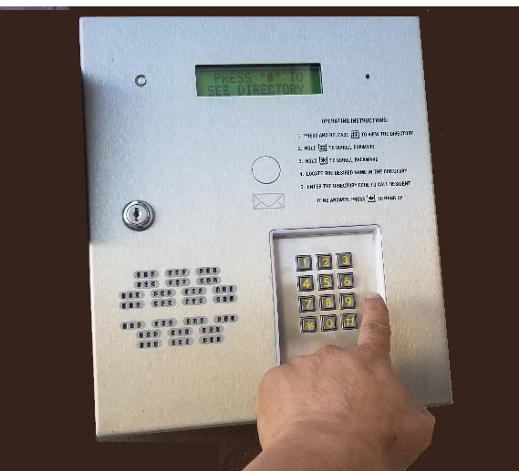 |  | Linear AE-100 Description  this is an Apartment Intercoms for more than a 100 units  The Linear AE-100 is a telephone entry system designed for one door access control for apartments, condominiums and offices with 125 residents or less.  This telephone entry device is typically used outside or in the main lobby. It uses full duplex phone communications between visitors and residents to grant access.  The AE-100 is housed in a locked and rugged stainless steel faced cabinet and has a lighted 12 key phone style keypad and 4 operation buttons with bright easy to view graphics. The directory is backlit and two line LCD / scrolling and includes a programmable welcome message.  The Linear AE-100 comes with a built in microphone, speaker, and TTY connector for ADA compliance. The unit controls electric strikes and maglocks, doors, gates, gate operators and barrier gate operators.  A single phone line can host up to four Linear AE-100's and allows for simple transfer of programming data from the master unit to all other units.  Available in English, Spanish, French-Canadian or Portuguese. Supports postal lock and CCTV camera. Powered from 16VAC transformer and supports an internal rechargeable battery..

Linear AE-100 Specifications

- 9.75" x 11.75" x 3.5"
- Supports color camera and postal lock
- Load shed circuitry for battery backup protection
- TTY Jack for the hearing impaired
- Stainless steel front panel
- 125 directory listings
- Multiple installation choices - wallmount, recessed, gooseneck
- Network capable up to 4 units
- Removable terminal blocks
- Telephone style keypad with lighting
- Installer friendly - two programming methods available
FEATURES:
- Many installation choices: surface, recessed, gooseneck
- Stainless steel front panel
- Telephone style keypad with lighting
- Accepts a total of 125 directory listings or standalone entry codes
- TTY jack for connection to text communication devices for the hearing impaired
- Simple network capability with up to four units - allows transferring programming data from "master" unit to other sub-units
- Two-line 16 character LCD display
- Removable terminal blocks
- Form "C" access relay rated at 10 amps AC and 7 amps DC @ 30 volts
- Load shed circuitry protects battery backup
- 9.75"W x 11.75"H x 3.5"D

