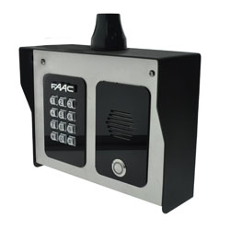 |  | FAAC FCI4000 Cellular Intercom 3G Model 4300  Hightlights: this is an Apartment Intercoms for more than a 100 units  - Calls your home phone and mobiles on roll-over when visitor presses the call button  - Open your gates from your phone  - Free home owner app to trigger gates, set up auto opening and closing times, create new access codes, receive notifications on entry, etc.  - Free installer app for remote programming and diagnostics  - Illuminated call button and keypad  - Works with an AT&T (4G or 3G) or T-Mobile Micro SIM card  - 2 Relays  - 24V dc power adapter included  - Stainless steel / aluminum housing  - Solar compatible  - Model with video capability available  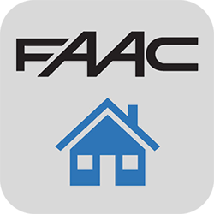  Technical Specifications:  - Power supply: 24 Vdc  - Power consumption: 80mA standby - 300mA during call - 2A peak  - Modem model: 3G  - Dial out numbers: 4  - Permanent codes: 200  - Time restricted codes: 20  - Temporary codes: 30  - Automatic trigger events per week: 40  - Caller ID numbers: 100  - Time restricted caller ID numbers: 20  - Relays: 2  - Relays type: N/C and N/O  - Relay Load: 2A - 24Vac max  - Operating ambient temperature: -22°F - 110°F (-30°C - +50°C)  - Weight: 4.7 lb ( 2.1 kg)  - Dimensions (L x D x H): 9 x 7 x 3 1/2 in (229 x 178 x 89 mm)  - Protection class: IP 55  - Enclosure: BS316 marine grade SS construction with gloss black face trim  Features:  - Set automatic gate open & close times.  - Do-not-disturb watershed time.  - User history log to your phone.  - Illuminated call button and keypad.  - Add keypad codes by App.  - Issue time restricted codes.  - High gain antenna as standard!  - 2x Relays
MORE INFO

