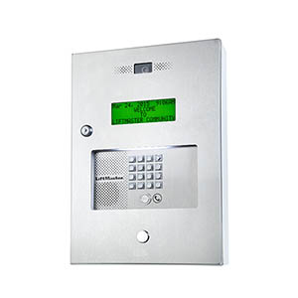 |  | Elite EL2000 Telephone Entry System Apartment Intercoms for more than a 100 units  The EL2000 will change your expectations of what a telephone entry system should look like. The EL2000 is designed to complement virtually all gated community and is flexible enough to be used in apartment buildings, condo complexes, office parks and commercial sites.  The EL2000 features a 5-inch backlit LCD screen; the unit clearly displays up to 4 lines with 20 characters per line, making it a great choice for multi-tenant installations. The EL2000 is capable of accepting up to 2,000 totally flexible codes. These codes can be programmed as directory codes or access codes, making the EL2000 ideal for virtually any installation. Unlike other systems, the EL2000 may be purchased as a base unit or can be ordered with optional plug-in modules. This allows you to choose only the plug-in modules you need depending on the specifics of the job - enabling you to offer custom solutions right off the shelf without special orders.  Optional modules let you expand the system to fit your specific needs. The Wiegand output module lets you add card readers and/or remote keypads. Our RF module provides convenient access through gates or doors with PassportTM transmitters. Plus, the system is now designed to automatically detect the addition and location of each new plug-in module, making installation and programming faster and easier than ever before.
FEATURES:
- Call waiting
- Recessed, lighted, ADA applicable keypad
- Auto sensor input
- Non-volatile memory
- Daylight savings/leap year
- Call button
- Distinctive ringing
- Entry codes
- Holiday programming
- Time zone
- Anti-passback
- Security lockout
- Automatic gate/door unlock schedule
- Transaction monitoring
- Activity reports
- Remote updates
- Postal lock provision

