Allomatic SL-150 AC Slide Gate Opener 1HP

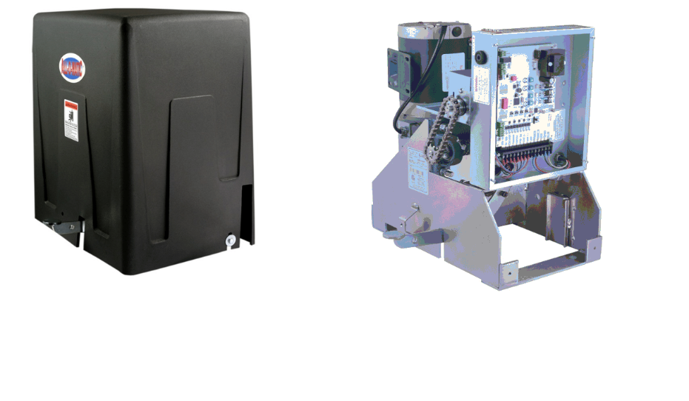
- Max gate size: 60ft
- Max gate weight: 2,500 lbs.
- 1 horsepower motor
The Allomatic SL-150 AC Slide Gate Opener is designed for heavy traffic at commercial and industrial locations, and can also endure extreme weather positions. The SL-150 AC Slide Gate Operator has a reliable gearbox with a heavy duty frame and a powerful AC motor. Depending on horsepower the gate opener can pull a gate 1500 - 2500 lbs. Allomatic SL-150 AC Slide Gate Operator has a simple and depenable circuit board, and a motor that has been field tested for over 20 years, and come with foot pedal for manual release.

Specs:
- Limited Warranty: 7 year residential and 5 year commercial
- Motor: 1 HP
- Duty Cycle: Continuous
- Power Options: 120VAC
- Gear Box Ratio: 30:1 w/ Internal Clutch
- Cover: Rotationally Molded – Indestructible
- Dimensions: W: 15" - L: 19.5" – H: 25"
- Max Gate Length: 60ft
- Maximum Gate Weight: 2,500lbs
- Gate Travel Speed: 12 inches per second
- Emergency release: Foot pedal

Manufacturers Warranty:
The Warrantor warrants All SL-100, SL-150, OH-200, SW300 and SW350 Gate Operators. ALL-O-MATIC INC warrants its gate openers for a period of five (5) years in commercial installations, and for a period of seven (7) years in residential installation to be free from defects in circuitry, motor, gear box and workmanship. This warranty applies from the date of purchase to the original owner.Warrantor will repair or, at its option, replace any device which it finds to require service. This device must be sent to the warrantor at the consumerâ€™s expense. The warrantor will return the repaired or replaced unit to the customer at the consumerâ€™s expense. Labor charges for dealer service or replacement are the responsibility of the owner. These warranties are in lieu of all other warranties either expressed or implied, and ALL-O-MATIC INC shall not be liable for consequential damage. All implied warranties of merchantability and or fitness for a particular purpose are hereby disclaimed and excluded. This limitation is not valid in jurisdictions which do not allow limitation of incidental or consequential damages or limitation of warranty periods. Caution in order to obtain this policy, please complete the registration card and send it by mail within 30 days of purchasing from ALL-O-MATIC INC. or your INSTALLER. If not registered only a one year warranty on all parts will be provided.

Video link

https://www.youtube.com/watch?v=DZvTj-j1ues
owner manual link
https://cdn.shopify.com/s/files/1/1666/9427/files/SL-150_AC_user_manual.pdf?10533160531761469514

