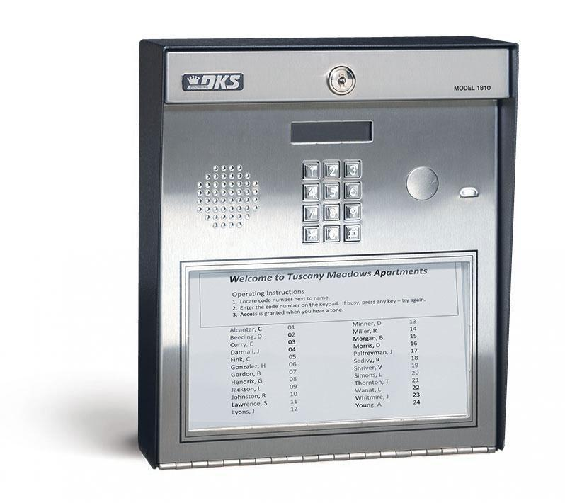 |  | 1810 Access Plus DKS DOOKING  MEDIUM MULTI-RESIDENT/TENANT COMPLEXES  The 1810 Access Plus is a versatile PC Programmable Telephone Entry System that provides voice communication from the entry point to the resident or tenant. With the easy-to-use Access Plus Account Manager programming software, you can customize the system immediately. The 1810 Access Plus incorporates a built-in LED lighted paper directory that can be printed directly from the Software. An additional 23 numbers can be programmed when used with the 1816 Access Plus Intercom Expansion. The 1810 is ideal for residential, multi-home, small gated community or apartment house applications. Access Plus models do not have any programming display or electronic directory. Display area is covered with dark plastic on this model.  The Access Plus line combines essential features of our most versatile solutions with the ease and accessibility of computer programming and control. Each Access Plus Series unit allows Voice and Data connection over either Cellular, VoIP or POTS (Plain Old Telephone Service). DKS offers easy ways to connect fast using the DKS IM Server and DKS Cellular services. With the easy to use Access Plus Account Manager programming software, you can customize the system immediately. Set up time zones, add or delete access codes, set up email notifications, and even lock or un-lock a door with the click of the mouse button.  The Model 1810 Access Plus provides voice communication from the entry point between the resident/tenant and guest.  The 1810AP is ideal for residential, multi-home, small gated community or apartment house applications. It features a built-in lighted directory that can be printed directly from the Access Plus Account Manager software.  DoorKing's Access Plus Account Manager Software is a powerful, flexible and easy to use computer program that allows you to manage access control in a variety of controlled access applications.  Download Access Plus Programming Software  NOTES for Access Plus download:  Use this software with Access Plus systems with circuit board 1970-010 only. (This software cannot be used to program 1812 systems with 1871-010 or 1971-010 circuit boards.)  This program will operate in Windows 2000, Windows NT, Windows XP*, Windows Vista, Windows 7 - 8 - 10.  *This program will function with Windows XP provided that Microsoft continues their support of the XP downgrade DLL. If Microsoft discontinues their support of the downgrade DLL, we will discontinue support of Windows XP.  Access Plus Account Manager Download  Simple to use Software for Access Control with your Internet Connection!  Connection Options  Use your PC to program online 24/7. A complete turn-key access management solution. Each Access Plus unit allows Voice and Data connection over either Cellular, VoIP, Wireless, or POTS. Simple yet powerful.  PC Programmable  Access Plus systems for smaller applications at a much lower cost. Control two entry points for up to 27 users - easily expandable to control an additional six entry points.

